CASE STUDY

**AIM:**

COVID-19 Vaccinations Trend Analysis

**INTRODUCTION:**

Analysing and visualizing the latest situation of “**Covid19 Vaccination**“ around the world. We will use POWER BI for data visualization & for data analysis.

**PROBLEM STSTEMENT:**

* Analysis preparation
* What vaccines are used in each country?
* Which vaccines used most?
* How many are vaccinated?
* How the vaccination progressed

**METHODOLOGY:**

Analysing and visualizing the latest situation of “Covid19 Vaccination“ around the world. We will use POWER BI for data visualization & for data analysis.

Data collecting method:

We imported the data into POWER BI.

Removed NULL values.

Columns in dataset:

* Country
* ISO Code
* Date
* Total number of vaccinations
* People vaccinated
* People fully vaccinated ;
* Daily vaccinations (raw)
* Daily vaccinations
* Total vaccinations per hundred
* People vaccinated per hundred
* People fully vaccinated per hundred
* Number of vaccinations per day
* Daily vaccinations per million
* Vaccines used in the country
* Source
* Source website

**ANALYSIS:**

***Total vaccinations by country:***

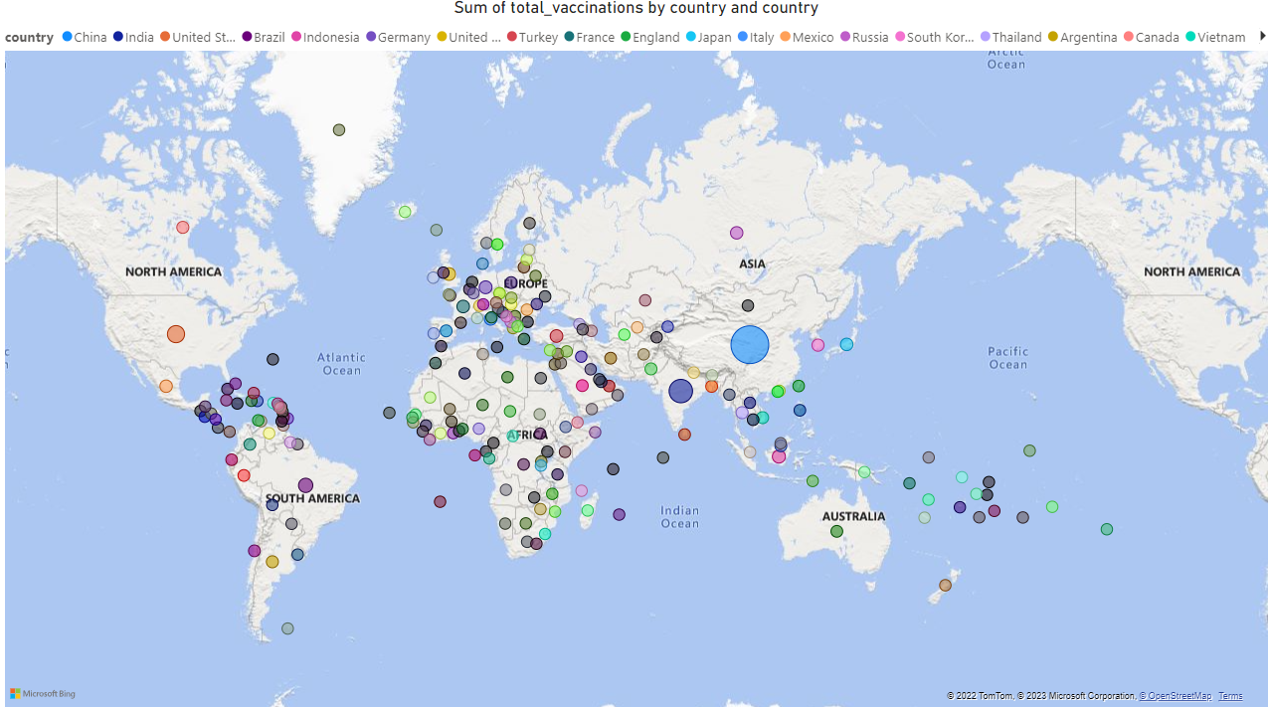

﻿China accounted for 35.42% of Sum of total_vaccinations.

﻿Across all 223 country, Sum of total_vaccinations ranged from 348 to 709452663700.

***Country and vaccines:***

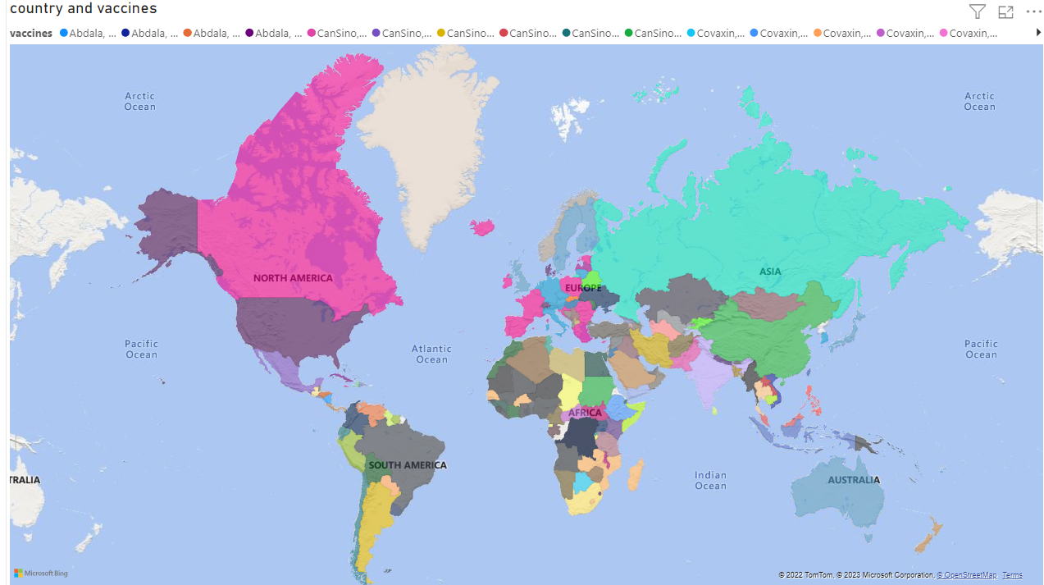

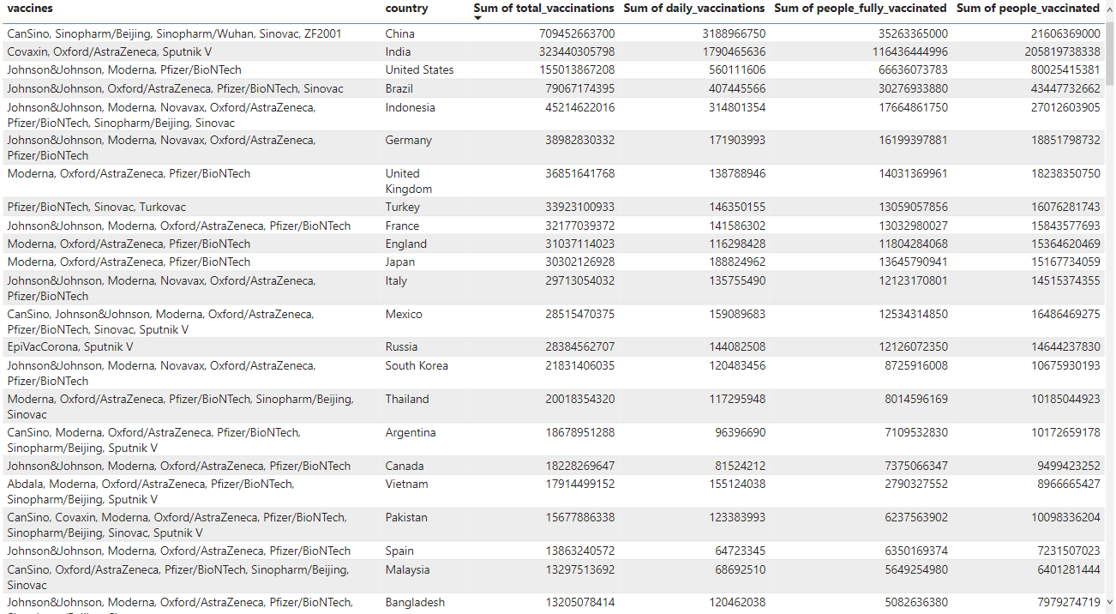

***Which vaccines used most?***

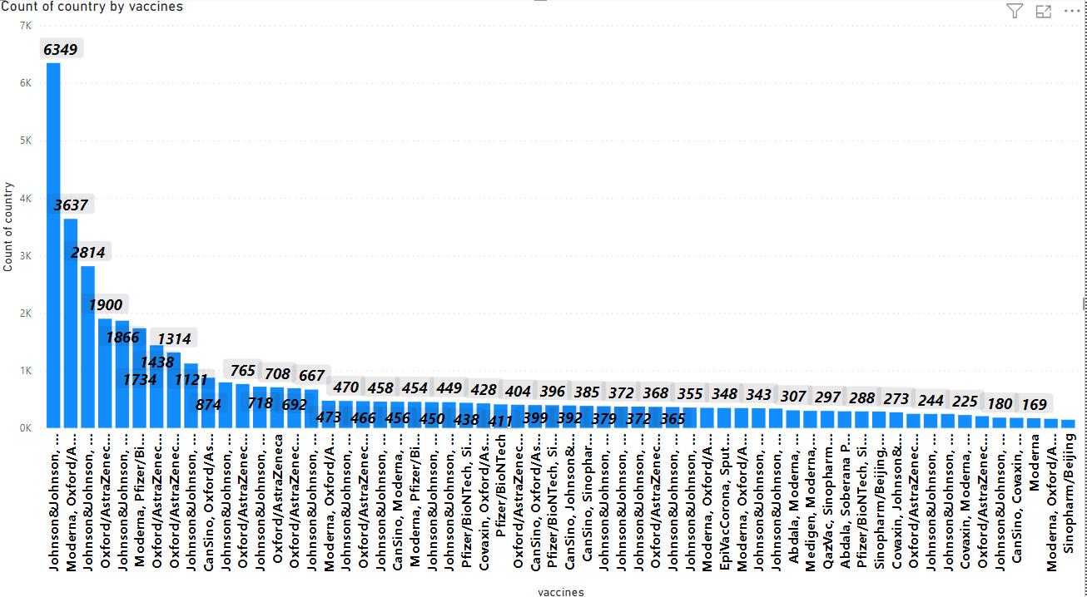

﻿Johnson&Johnson, Moderna, Oxford/AstraZeneca, Pfizer/BioNTech had the highest Count of country at 6,349, followed by Moderna, Oxford/AstraZeneca, Pfizer/BioNTech and Johnson&Johnson, Moderna, Novavax, Oxford/AstraZeneca, Pfizer/BioNTech. EpiVacCorona, Oxford/AstraZeneca, QazVac, Sinopharm/Beijing, Sputnik V, ZF2001 had the lowest Count of country at 3.

﻿Across all 84 vaccines, Count of country ranged from 3 to 6,349.

***Vaccination of country by years:***

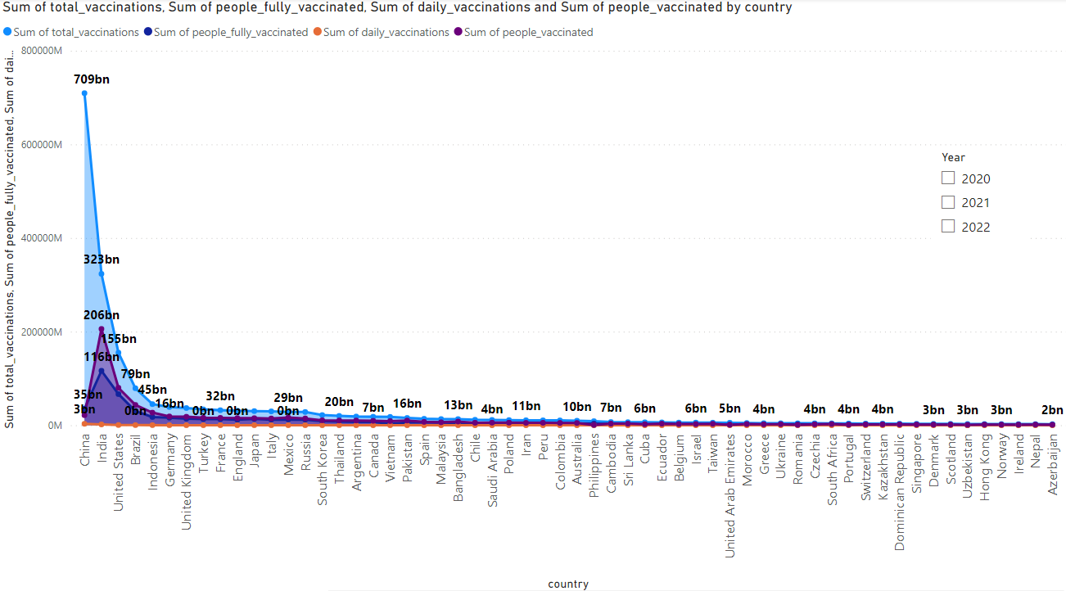

Across all 223 country, Sum of total_vaccinations ranged from 348 to 709452663700, Sum of people_fully_vaccinated ranged from 113 to 116436444996, and Sum of daily_vaccinations ranged from 2 to 3188966750.

***Vaccination by year:***

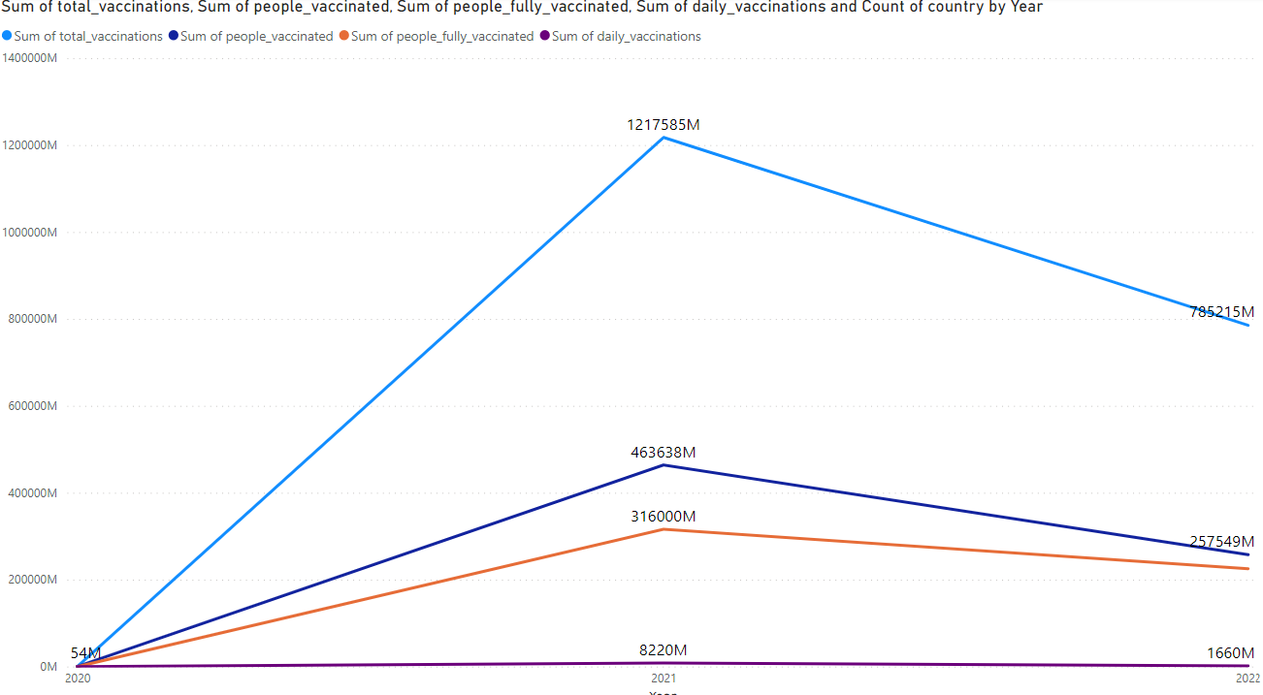

﻿Sum of people_fully_vaccinated jumped from 321734 to 225270572442 during its steepest incline between 2020 and 2022.

***Vaccinations by country:***

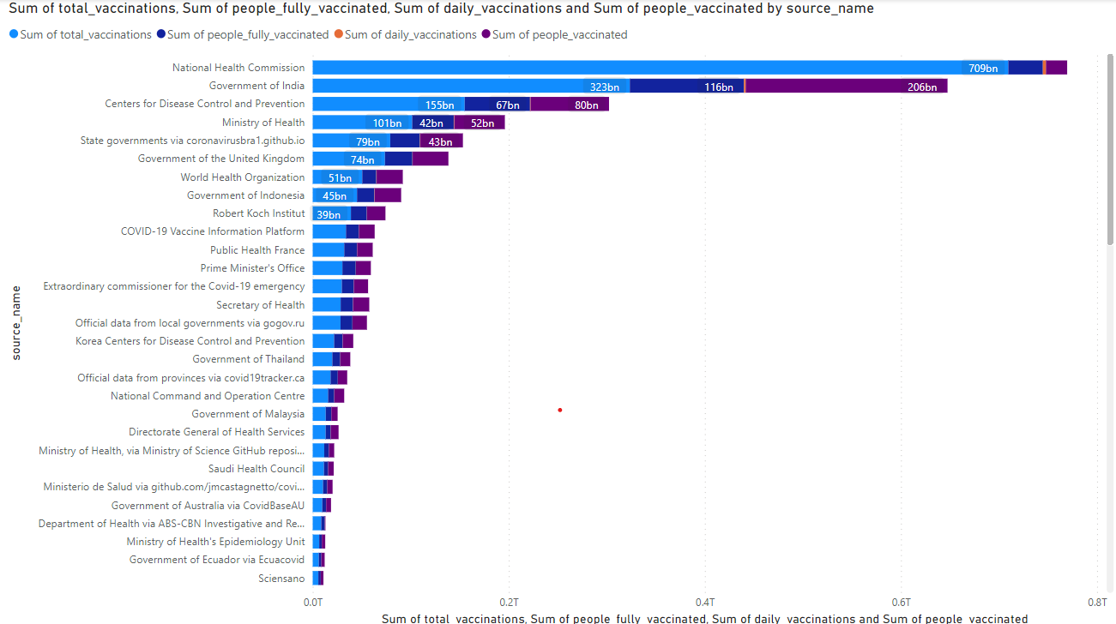

﻿Across all 81 source_name, Sum of total_vaccinations ranged from 14163 to 709452663700, Sum of people_fully_vaccinated ranged from 3492 to 116436444996, and Sum of daily_vaccinations ranged from 424 to 3188966750.

**INSIGHTS:**

total_vaccinations, people_fully_vaccinated, daily_vaccinations, people_vaccinated are mainly used for the analyse the dataset.

**CONCLUSION:**

China, India, United States has highest rate of vaccinations according to the data.

Johnson&Johnson, Moderna, Oxford/AstraZeneca, Pfizer/BioNTech had the highest Count of country at 6,349, followed by Moderna, Oxford/AstraZeneca, Pfizer/BioNTech and Johnson&Johnson, Moderna, Novavax.

According to the data the Vaccinations increased from 2020 to 2021,And decreased from 2021 to 2022 by this we can assume that the COVID-19 cases are reduced.